porta

Ignition QC Process Control System
  - Complete project framework for plant-wide digital process-control forms
Prepared for: Myrtleford Plant
Prepared by: Nguyen Trieu, Automation and Control Engineer
Document status: Concept and implementation framework
Version: Draft 0.1
Date: 16 July 2026
PROJECT INTENT
Replace controlled paper and Excel process-control forms with authenticated, station-aware Ignition Perspective pages, a central SQL record, automated validation, managed non-conformance workflows, and QC/management visibility.

Executive summary
The project is a configurable electronic process-control platform, not a collection of one-off spreadsheet replicas. One reusable application framework will present the correct controlled form at each production station, apply the correct effective-dated specification, record authenticated entries, evaluate compliance, initiate the appropriate recheck or escalation workflow, and create a searchable audit trail.
DESIGN PRINCIPLE
Build one reusable inspection and workflow framework; configure many forms. Preserve the company visual language: grey section bands, light work surfaces, strong black text, Porta red branding, yellow action/warning controls, bright green positive controls, and purple reject/review controls.

Contents
- 1. Vision, scope and outcomes
- 2. Source form landscape and form families
- 3. User roles and journeys
- 4. UX design system and company theme
- 5. Operator data-entry mockup
- 6. QC manager dashboard mockup
- 7. Status, validation and pulsing animation
- 8. Functional architecture
- 9. Data architecture and audit model
- 10. Form, specification and schedule configuration
- 11. Non-conformance workflow
- 12. Ignition Perspective implementation pattern
- 13. Security, authentication and electronic identity
- 14. Reporting and dashboards
- 15. Integration, availability and recovery
- 16. Testing and acceptance
- 17. Delivery roadmap and governance
- 18. Deliverables and exportable package
- Appendix A. Example CSS and binding logic
- Appendix B. Page and component catalogue
- Appendix C. Initial risk register

1. Vision, scope and outcomes

1.1 Vision
Develop a plant-wide Ignition Perspective application that digitises process-control sheets, tracking logs, setup records, time sheets and QC checks. Operators use a tablet or PC at each station; QC and management use central exception, HOLD, compliance and trend views.

1.2 Scope
In scope | Description
Digital data entry | Responsive station pages, current-shift logs, draft/save/submit and controlled correction.
Rules and specifications | Effective-dated minimum, target and maximum values selected by product, grade, thickness, variant, station and form revision.
Scheduling | Hourly, two-hourly, per-load, per-pack, per-event, shift-start and post-failure increased-frequency checks.
Workflow | Rechecks, comments, role notifications, HOLD, stop-process, maintenance involvement, verification and QC closure.
Records | SQL inspection headers, individual measurements, applied specification snapshot, audit events and exception history.
Insights | Live exception queue, compliance, overdue checks, HOLD register, calibration, trends and exports.

1.3 Success measures
- No paper form required at a commissioned pilot station.
- Every submitted result is linked to user, station, shift, product/pack or load, timestamp, form revision and applied specification.
- Out-of-specification results are identified immediately and the required workflow cannot be skipped.
- Submitted records cannot be silently overwritten; corrections are reasoned and auditable.
- QC can find records and open exceptions without searching paper archives.
- A second and third form can be commissioned primarily through configuration and reusable components.

2. Source form landscape and reusable form families
The current inventory includes approximately fifteen source documents spanning Lathe, Dryer, Composer, Core Stacker, Trim Saws, Saw Doctor, Layup, Peeler, Steamer and Sanding areas. The Form Register workbook remains the controlled discovery backlog.
Family | Typical forms | Reusable pattern
Dimensional / physical | Lathe Outfeed, Dryer Outfeed, Composer Outfeed, Sanding, Trim Saws | Grouped numeric measurements; positions; specification resolver; pass/fail and rechecks.
Repeated load / batch | Dryer Infeed, Composer Infeed, Core Stacker | Parent shift/production record with repeated child entries.
Time / duration | Layup Outfeed, Steamer Cart | Start/finish events, calculated duration, delay reason and notification.
Tooling / setup | Knife Setup, Knife Grinding | Equipment/tool ID, setup dimensions, approval, condition and lifecycle evidence.
Attribute inspection | Stamp, sand quality, T&G, tight scribe | Yes/No, Pass/Fail or controlled selection; comments/evidence on failure.
Scheduled compliance | Hourly, two-hourly, shift-start, post-failure | Due-soon/due/overdue scheduler and increased-frequency logic.

SOURCE CONTROL
The Excel/PDF layout is evidence of current requirements, not the target screen design. Every form revision, characteristic and action rule must be confirmed with the business owner before production release.

3. User roles and journeys
Role | Primary permissions and experience
Operator | Open station checks, enter measurements, save draft, submit, complete rechecks, add comments and view current-shift records.
Shift QC | Monitor exceptions, acknowledge failures, review rechecks, manage HOLD and enter disposition.
Team Leader / Shift Manager | See due/overdue checks, acknowledge escalation, confirm process actions and monitor shift compliance.
QC Manager | Approve specifications/workflows, review trends, manage exceptions, audit records and export reports.
Administrator | Configure forms, stations and integrations; maintain technical operation without routine authority to alter submitted QC evidence.

3.1 Operator journey
- Sign in or resume authenticated session.
- Station home shows current context and due work.
- Start the due check; verify product, pack/load and measuring equipment.
- Enter only values not available automatically.
- Receive immediate field and process validation.
- Save draft or submit.
- See the new record at the top of the current-shift log.
- If failed, follow the displayed recheck/escalation/HOLD workflow.

3.2 Manager journey
- Open dashboard to see overdue checks, open exceptions, HOLD and calibration risk.
- Prioritise the exception queue by severity and age.
- Open an exception to see measurements, applied limits, rechecks, notifications and audit trail.
- Assign or acknowledge work; record disposition and closure.
- Review compliance and recurring failure trends by area, station, product and characteristic.

4. UX design system and company theme
The supplied company screen uses a white/light-grey application surface, Porta red wordmark, grey section bars and alternating striping. Yellow buttons identify non-structural or attention selections, bright green identifies pallet/positive selection, and light purple identifies reject/review actions. The new QC project should follow the pattern while improving hierarchy, accessibility and state clarity.
Token | Recommended use | Colour
Porta red | Brand, page title accent, critical emphasis | D7194B
Dark charcoal | Primary text and table header | 343A40
Light grey | Page background and disabled/read-only context | F3F3F3
Mid grey | Section bands and alternating process rows | A6A6A6
Yellow | Warning, action required, recheck | FFF200
Bright green | Pass, current, success, positive action | 00E62E
Light purple | Reject, QC review, disposition or HOLD-related control | 9999FF
Red | Failed measurement and critical exception | E53935

4.1 Core interaction rules
- Keep station, shift, user, product, pack/load, revision and connection status visible.
- Use large touch targets; make primary controls approximately 48-56 px high.
- Show units and the applicable limits next to every numerical input.
- Use physical positions such as RHS/MID/LHS instead of ambiguous numbering where possible.
- Derive target/specification from product and configuration; do not let an operator select an unrelated tolerance.
- Use colour plus status text, icon and explanation; colour alone is insufficient.
- Keep current work primary; show only concise recent history beside it.
- Do not clear the entry page until the database confirms submission.

5. Operator data-entry mockup
The proposed large-screen layout retains the requested side-by-side pattern: current inspection on the left and the current-shift log on the right. The mockup follows the company grey-band and bright action-colour pattern while adding limits, explicit status, workflow guidance and shift compliance.
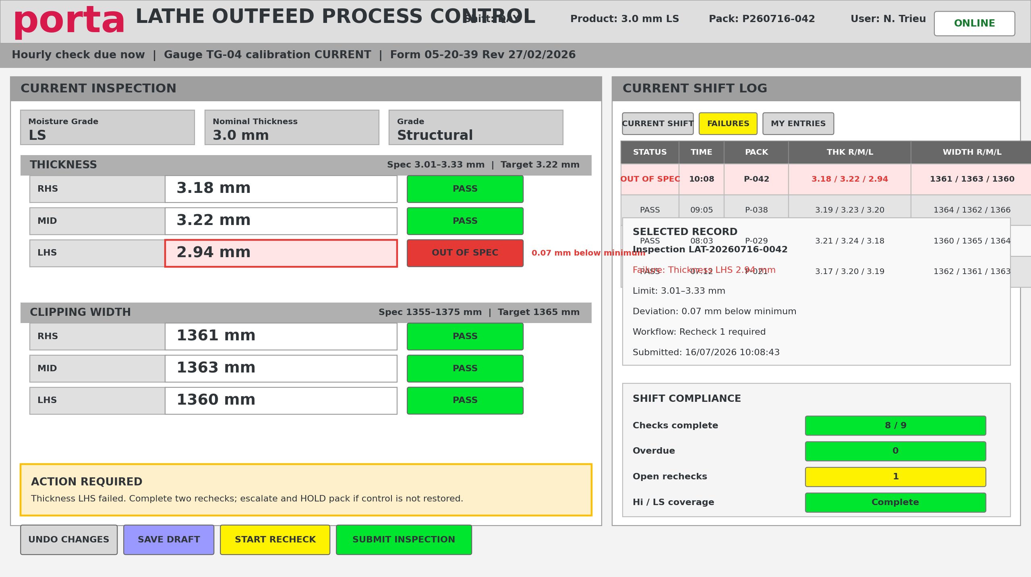
Figure 1. Proposed Lathe Outfeed operator page - concept only.

5.1 Layout behaviour
- Desktop/large landscape tablet: 55-65% entry panel and 35-45% recent log.
- Portrait tablet: entry form first, followed by three to five recent records.
- The latest submitted record appears at the top and receives a brief confirmation highlight.
- The current-shift log leads with Status and avoids primary horizontal scrolling.
- Selecting a history row opens full inspection detail and audit information.
- The action area shows the next required step rather than leaving the operator with only a red field.

6. QC manager dashboard mockup
The manager experience is exception-led. Summary cards show workload and risk; the live queue prioritises action; compliance and trend panels explain recurring issues; the process matrix exposes station-level status.
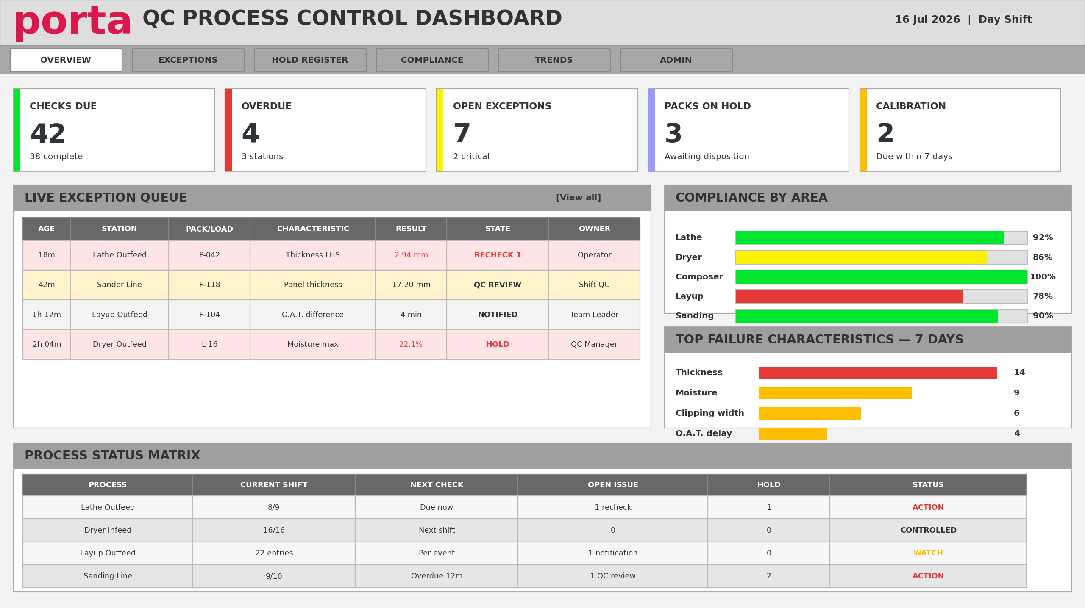
Figure 2. Proposed QC manager overview dashboard - concept only.

6.1 Core manager views
View | Purpose
Overview | Checks due/completed/overdue, open exceptions, HOLD, calibration and process status.
Exception queue | Severity, age, station, pack/load, failed characteristic, workflow state and accountable owner.
Exception detail | Complete inspection, limit snapshot, rechecks, notifications, comments, evidence, disposition and audit timeline.
HOLD register | Affected product, issue, quantity/packs, location, owner, disposition and release authority.
Compliance | Required versus completed checks by process, station, shift and form.
Trends | Thickness, width, moisture, timing, failure rates, recurring characteristics and response times.
Administration | Controlled forms, revisions, characteristics, specifications, schedules, equipment and notifications.

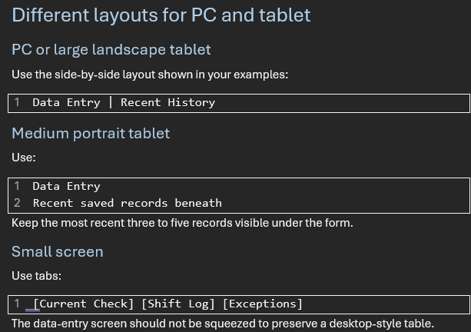

7. Status, validation and pulsing animation

7.1 Status model
State | Presentation | Behaviour
Not entered | Neutral grey | No result yet.
Unsaved / draft | Blue or purple status | Value exists but does not count as a completed check.
Pass | Green badge/border plus PASS | Within specification.
Warning | Yellow/amber plus WARNING and reason | Near limit, due soon, calibration approaching expiry or other agreed warning rule.
Out of spec | Red border/fill plus OUT OF SPEC and deviation | Creates required recheck/exception workflow.
QC review | Purple plus QC REVIEW | Measurement recorded; authorised disposition pending.
HOLD | Purple/red plus HOLD | Affected product blocked until disposition/release.

7.2 Animation rule
Use animation only when a result first changes into Warning or Failed. Pulse the field and/or status badge for approximately 2-4 seconds, then retain a solid warning/fail style. Never rely on perpetual flashing as the only alarm, and avoid animating an entire table. Respect reduced-motion preferences.
RECOMMENDED
A failed value receives a short three-cycle pulse, a persistent red border and pale-red fill, an OUT OF SPEC label, a deviation message, and a visible next-action panel. A warning uses amber/yellow in the same pattern.

7.3 Perspective implementation options
- Built-in animated Style Class: define key stops and bind the component style class to the validation state.
- Advanced Stylesheet (Ignition 8.1.22+): define project-scoped keyframes and apply a psc- prefixed Style Class.
- Event flag: set a transient pulse flag when a value transitions to warning/fail; clear the flag after the animation period while leaving the persistent status class active.
- Table rows/cells: use row/cell style rules for persistent highlighting; animate only the newly created or newly failed item.

8. Functional architecture
The architecture separates station experience, shared business logic, data persistence and management insight. Form screens should not contain duplicated specification or workflow logic.
Layer | Responsibilities
Station context | Configured station/device, user, shift, product, order, pack/load/cart and machine state.
Form renderer | Loads form revision, sections, characteristics, controls, visibility and display order.
Specification resolver | Selects the one approved effective specification and returns minimum/target/maximum/unit.
Validation engine | Validates data type, plausibility, required fields, specification result and form-level rules.
Scheduler | Creates/checks due work and manages due-soon, overdue and increased-frequency states.
Workflow engine | Rechecks, notifications, HOLD, stop-process, maintenance, verification and closure.
Persistence service | Transactional saves, idempotency, specification snapshot and audit events.
Reporting layer | Current-shift logs, queues, dashboards, trends and controlled exports.

9. Data architecture and audit model
Entity | Purpose
qc_form_definition | Controlled form identity, title, reference, owner and process.
qc_form_revision | Effective-dated approved revision and lifecycle state.
qc_section_definition | Logical screen sections.
qc_characteristic_definition | Field/data type, unit, precision, positions, display order and rules.
qc_specification | Product/grade/variant/station dependent limits and approval.
qc_schedule_rule | Frequency, first-check offset, grace, applicability and post-failure frequency.
qc_inspection | Inspection header: context, user, times and overall state.
qc_measurement | Individual entered/calculated value and applied-limit snapshot.
qc_nonconformance | Failure, severity, workflow, HOLD and closure.
qc_workflow_event | Recheck, notification, acknowledgement, action, disposition and verification.
qc_audit_event | Old/new value, action, reason, user, timestamp and source.
equipment_calibration | Instrument identity, due date, status and evidence.

9.1 Non-negotiable record rules
- Store the specification values applied at submission; historical pass/fail must not change when a future specification changes.
- Use database-generated inspection IDs and an idempotency key to prevent duplicate saves.
- Save inspection header, measurements, exception creation and audit event in one transaction.
- Submitted results are immutable to ordinary users; corrections create a controlled amendment.
- Record sample time separately from submitted time and corrected time.
- Use soft retirement/effective dating for configuration; do not delete historical definitions referenced by records.

10. Configurable form, specification and schedule framework

10.1 Form definition
- Form reference, title, revision, issue/effective dates and owner.
- Applicable process, station and role.
- Sections and field display order.
- Input component type, unit, precision and required state.
- Calculation rule, visibility rule and failure message.

10.2 Specification resolution
Resolve the most specific approved specification matching the active date, form revision, characteristic, product, grade, nominal thickness, variant/veneer type and station. If zero or multiple equally valid rules are found, block submission and raise a configuration exception rather than guessing.

10.3 Schedule types
Type | Example
Shift start | First hourly check within 30 minutes of shift start.
Interval | Hourly or two-hourly.
Per event | Every pack/load/cart or process event.
Coverage | At least one Hi and one LS pack per shift.
Product change | Check when product/grade/nominal changes.
Post-failure | Every 30 minutes until control is restored.
Post-adjustment | Verify first pack after repair or adjustment.

11. Non-conformance workflow
Workflow steps are configurable by form and characteristic; Lathe, Layup and Sanding do not share identical action plans.
1. Failure detected and immutable failed measurement recorded.
2. Display deviation and immediate operator instruction.
3. Require reason/comment where applicable.
4. Create Recheck 1 and Recheck 2 according to the controlled action plan.
5. If control is restored, retain the full history and final outcome.
6. If not restored, notify configured roles and create an exception.
7. Apply HOLD/stop-process/maintenance actions when configured.
8. Capture affected packs/loads and first-off verification.
9. QC records disposition and authorised release/closure.

11.1 Exception state model
OPEN -> RECHECK REQUIRED -> ESCALATED -> HOLD / ACTION IN PROGRESS -> VERIFICATION REQUIRED -> QC REVIEW -> CLOSED, with CANCELLED only for an authorised duplicate/invalid workflow and never as a method of erasing evidence.

12. Ignition Perspective implementation pattern

12.1 Page structure
/station/home
/station/inspection/:inspectionId
/station/shift-log
/qc/exceptions
/qc/exception/:exceptionId
/qc/hold-register
/manager/overview
/manager/compliance
/manager/trends
/admin/forms
/admin/specifications
/admin/schedules

12.2 Shared views/components
shared/HeaderContext
shared/DueCheckBanner
shared/ProductionContext
shared/CalibrationPanel
shared/MeasurementGroup
shared/NumericMeasurement
shared/AttributeMeasurement
shared/TimeMeasurement
shared/StatusBadge
shared/ActionRequiredPanel
shared/CurrentShiftLog
shared/SaveSubmitBar
shared/AuditTimeline

12.3 Named-query groups
- Configuration: active form, revision, sections, characteristics, specification and schedule.
- Inspection: create draft, load draft, transactional submit, current shift history and detail.
- Workflow: create exception, add recheck, notify/acknowledge, HOLD, disposition and close.
- Reporting: compliance, overdue, trend series, exception queue and calibration risk.

12.4 Scripting principles
- Place shared logic in project library scripts, not individual component event scripts.
- Use parameterised named queries for database access.
- Define one status evaluation contract used by input components, history tables and dashboards.
- Use structured logging with inspection ID, station and user context.
- Handle database failure explicitly and never show a success state until commit confirmation.

13. Security, authentication and electronic identity
- Use an approved Ignition Identity Provider and security levels/roles.
- Display signed-in identity continuously and require user changeover on shared devices.
- Use role-based access for correction, specification approval, HOLD release and system administration.
- Record authentication identity rather than typed initials as the primary electronic attribution.
- Use idle timeout appropriate to the station, with safe handling of unsaved drafts.
- Authorise every named query and sensitive page server-side; hiding a component is not sufficient security.
- Log specification approval, correction, disposition and release as high-value audit events.
SEPARATION OF DUTIES
Where quality governance requires it, the person entering a result should not be the only person permitted to approve a specification change, release HOLD product or close a critical exception.

14. Reporting and dashboard framework
Metric / view | Definition
On-time completion | Completed required checks / due checks within agreed grace.
First-pass compliance | Inspections passing without recheck / submitted inspections.
Open exception age | Time since failure or escalation, by severity and owner.
HOLD ageing | Time from HOLD creation to disposition/release.
Recheck success | Failures restored within configured rechecks.
Failure Pareto | Count/rate by process, station, product, characteristic and shift.
Specification trend | Actual values plotted against the applied min/target/max snapshot.
Calibration risk | Expired and due-soon instruments used by inspection process.
Data quality | Drafts abandoned, missing context, corrections and duplicated attempts.

SPC and capability metrics should be introduced after data definitions, sampling assumptions and measurement systems are validated. A dashboard should not imply statistical control solely because values are displayed over time.

15. Integration, availability and recovery

15.1 Integration priorities
- PLC/machine tags: active product, recipe, states and timestamps where reliable.
- Production/ERP: order, product, grade, nominal, pack/load and genealogy identifiers.
- Barcode/QR: pack, load, cart, tool and gauge identification.
- Calibration source: equipment status and due date.
- Notifications: approved channels for QC, team leader, supervisor and maintenance.

15.2 Connection-loss behaviour
- Always show gateway/database connectivity state.
- Define whether drafts can be kept locally or must remain gateway-backed.
- Never claim submission success without committed database confirmation.
- Use an idempotency token so a retry cannot create a duplicate inspection.
- If offline entry is allowed, label it OFFLINE PENDING and prevent dependent workflows until synchronised.
- Document recovery, backup and restore objectives and test them before rollout.

16. Testing and acceptance
Test class | Examples
Boundary values | Exactly minimum, exactly maximum, just below/above, decimal precision and unit conversion.
Specification selection | Every product/grade/variant combination; no match and duplicate match must fail safely.
Workflow | Pass, warning, first failure, recheck pass, repeated failure, HOLD, maintenance and closure.
Security | Operator versus QC/manager/admin access; direct URL and named-query enforcement.
Concurrency | Two sessions, duplicate tap, stale draft and simultaneous QC action.
Network | Latency, gateway disconnect, database unavailable and retry.
Usability | Gloves, mounted tablet, lighting, keyboard-only PC entry and full-shift repetition.
Record integrity | Audit old/new values, sample/submission times and immutable applied specification.
Performance | Agreed response thresholds under representative users and record volumes.
FAT/SAT | Controlled test scripts, expected result, evidence, defect and business sign-off.

16.1 Minimum UX acceptance
- No primary horizontal scrolling on the agreed devices.
- The next required action is visible after every failure.
- A newly saved record is visible immediately with inspection ID and result.
- The operator can distinguish unsaved, draft, submitted, pending and corrected states.
- Every status uses text in addition to colour.
- Touch controls and text remain usable at production stations.

17. Delivery roadmap and governance
Phase | Outcome
0. Discovery | Controlled form register, field inventory, specification matrix, schedule and workflow decisions.
1. Foundation | Database, authentication, station context, audit, form renderer and common components.
2. Pilot - Lathe Outfeed | Numerical specifications, positions, hourly checks, rechecks and HOLD.
3. Pilot - Layup Outfeed | Event timestamps, calculated duration and notification workflow.
4. Pilot - Sanding Line | Mixed inputs, product tolerance matrix, calibration and increased-frequency checks.
5. QC operations | Exception queue, HOLD register, disposition and calibration views.
6. Management | Compliance, trends, reports and governance controls.
7. Rollout by family | Remaining forms migrated using the validated framework.
8. Optimisation | PLC/ERP/barcode integration, advanced analytics and continuous improvement.

17.1 Governance
- Business owner approves the digital interpretation of each controlled form.
- Quality approves specification, action plan, audit and retention rules.
- Automation owns reusable project code and technical standards.
- IT owns infrastructure, backup, identity and cyber controls as agreed.
- Each release has requirements traceability, FAT/SAT evidence and rollback plan.

18. Deliverables and exportable package
Ignition-QC-Framework/
01_Project_Definition/
02_Requirements/Form_Register.xlsx
03_Database/Schema.sql, Seed.sql, Data_Dictionary.xlsx
04_Ignition/Project_Export.zip, resources, scripts, named queries
05_UX/Wireframes, component catalogue, style guide
06_Testing/FAT.xlsx, SAT.xlsx, traceability.xlsx
07_Deployment/environment, backup, rollback, cutover
08_Training/operator and QC guides

The final importable Ignition package must be aligned to the installed Ignition version, modules, database engine, identity provider, environment names and project export format. The design framework is version-independent; the executable package is environment-specific.

18.1 Immediate next artefacts
- Complete the Form Register for all source documents.
- Confirm target Ignition version and database platform.
- Define device/resolution matrix and station configuration.
- Approve the UX theme, status palette and animation policy.
- Create the logical/physical data model and first schema migration.
- Build reusable NumericMeasurement, StatusBadge, CurrentShiftLog and ActionRequiredPanel components.
- Implement Lathe Outfeed as the foundation pilot.

Appendix A. Pulsing animation example
For Ignition 8.1.22 or later, enable the Advanced Stylesheet under Perspective > Styles. Perspective injects Style Classes with the .psc- prefix. The component should have a persistent state class and a temporary pulse class.
/* Persistent states */
.psc-qcFieldFail {
background: #ffe5e5;
border: 3px solid #e53935;
color: #222;
}
.psc-qcFieldWarning {
background: #fff7cc;
border: 3px solid #ffbf00;
color: #222;
}
/* Temporary attention pulse: three cycles, then stop */
.psc-qcPulseFail {
animation: qcPulseFail 0.75s ease-in-out 3;
}
.psc-qcPulseWarning {
animation: qcPulseWarning 0.75s ease-in-out 3;
}
@keyframes qcPulseFail {
0%, 100% { box-shadow: 0 0 0 0 rgba(229,57,53,0); transform: scale(1); }
50% { box-shadow: 0 0 0 6px rgba(229,57,53,.35); transform: scale(1.015); }
}
@keyframes qcPulseWarning {
0%, 100% { box-shadow: 0 0 0 0 rgba(255,191,0,0); transform: scale(1); }
50% { box-shadow: 0 0 0 6px rgba(255,191,0,.35); transform: scale(1.015); }
}
@media (prefers-reduced-motion: reduce) {
.psc-qcPulseFail, .psc-qcPulseWarning { animation: none; }
}

Binding pattern
# Expression binding concept for props.style.classes
# persistentStatusClass + optional transientPulseClass
if({view.custom.status} = 'FAIL',
'qcFieldFail' + if({view.custom.pulse}, ' qcPulseFail', ''),
if({view.custom.status} = 'WARNING',
'qcFieldWarning' + if({view.custom.pulse}, ' qcPulseWarning', ''),
'qcFieldNormal'
)
)

Set pulse true only when the state transitions into FAIL/WARNING. Clear the pulse flag after the animation interval, but keep status FAIL/WARNING so the persistent style remains. The exact event/timer method should match the chosen Perspective component and project scripting standard.

Recommended behaviour
Do not continuously blink every failed field.
Use this sequence:
- Measurement changes to WARNING or FAIL.
- Field pulses for three cycles.
- Animation stops automatically.
- Persistent yellow or red styling remains.
- Status text and deviation remain visible.
- The associated workflow remains open until resolved.
This gets the operator’s attention without creating continuous alarm fatigue.
Advanced Stylesheet example
Enable:
1 Perspective
2 └── Styles
3 └── Enable Advanced Stylesheet
Then add:
1 /* Normal persistent statuses */
2
3 .psc-qcFieldFail {
4 background: #ffe5e5;
5 border: 3px solid #e53935;
6 color: #222222;
7 }
8
9 .psc-qcFieldWarning {
10 background: #fff7cc;
11 border: 3px solid #ffbf00;
12 color: #222222;
13 }
14
15 .psc-qcFieldPass {
16 background: #efffee;
17 border: 2px solid #00b52a;
18 color: #222222;
19 }
20
21 /* Temporary attention animations */
22
23 .psc-qcPulseFail {
24 animation: qcPulseFail 0.75s ease-in-out 3;
25 }
26
27 .psc-qcPulseWarning {
28 animation: qcPulseWarning 0.75s ease-in-out 3;
29 }
30
31 @keyframes qcPulseFail {
32 0%,
33 100% {
34 box-shadow: 0 0 0 0 rgba(229, 57, 53, 0);
35 transform: scale(1);
36 }
37
38 50% {
39 box-shadow: 0 0 0 6px rgba(229, 57, 53, 0.35);
40 transform: scale(1.015);
41 }
42 }
43
44 @keyframes qcPulseWarning {
45 0%,
46 100% {
47 box-shadow: 0 0 0 0 rgba(255, 191, 0, 0);
48 transform: scale(1);
49 }
50
51 50% {
52 box-shadow: 0 0 0 6px rgba(255, 191, 0, 0.35);
53 transform: scale(1.015);
54 }
55 }
56
57 /* Accessibility and reduced-motion support */
58
59 @media (prefers-reduced-motion: reduce) {
60 .psc-qcPulseFail,
61 .psc-qcPulseWarning {
62 animation: none;
63 }
64 }
Ignition’s Advanced Stylesheet is project-scoped, meaning the animation can be exported with the Perspective project rather than being maintained as an external Gateway theme asset. ³ ⁴
Applying the classes
Use two kinds of classes:
Persistent class
Remains while the condition exists:
1 qcFieldFail
2 qcFieldWarning
3 qcFieldPass
Temporary animation class
Applied only when the status initially changes:
1 qcPulseFail
2 qcPulseWarning
Conceptual binding:
1 if status == "FAIL":
2 styleClass = "qcFieldFail"
3
4 if pulse:
5 styleClass += " qcPulseFail"
6
7 elif status == "WARNING":
8 styleClass = "qcFieldWarning"
9
10 if pulse:
11 styleClass += " qcPulseWarning"
12
13 elif status == "PASS":
14 styleClass = "qcFieldPass"
15
16 else:
17 styleClass = "qcFieldNormal"
Important implementation rule
The pulse flag must be separate from the status.
For example:
1 status = FAIL
2 pulse = true
After approximately three seconds:
1 status = FAIL
2 pulse = false
The result remains solid red, but the animation stops.
If the operator changes the value and it returns to specification:
1 status = PASS
2 pulse = false
If a new value fails again, the pulse can be triggered again.
Built-in alternative
Ignition also supports animated Style Classes configured through the Style Class editor. An animated class transitions between multiple configured style stops over a defined duration. ⁵
The built-in editor is appropriate for simple colour transitions. The Advanced Stylesheet is more suitable when you want:
- Exactly three pulses
- Box-shadow effects
- Slight scaling
- Separate warning and failure animations
- Reduced-motion handling
- Precise timing

Recommended animation policy
Condition | Initial animation | Persistent appearance
Warning | Three amber pulses | Pale-yellow fill, amber border, WARNING
Out of specification | Three red pulses | Pale-red fill, red border, OUT OF SPEC
New successful submission | One brief green/teal highlight | Normal alternating history row
Overdue check | Brief amber pulse when becoming overdue | Amber OVERDUE status
Critical HOLD | Brief red/purple pulse when created | Solid HOLD badge and exception banner
Existing historical failure | No animation | Persistent red cell/row indicator
Only new or newly changed conditions should animate. Opening a page containing twenty historical failed records should not cause all twenty rows to flash.

Theme decisions captured in the framework
The proposed project theme uses:
1 Porta Red #D7194B
2 Dark Charcoal #343A40
3 Light Grey #F3F3F3
4 Mid Grey #A6A6A6
5 Warning Yellow #FFF200
6 Positive Green #00E62E
7 Review Purple #9999FF
8 Failure Red #E53935
9 Amber #FFBF00
The existing company theme remains recognisable, but the colours now have consistent meanings across every process-control form.
The next technical package can build directly on this framework with:
- SQL schema and data dictionary
- Ignition page and embedded-view structure
- Shared Style Classes and Advanced Stylesheet
- Named-query catalogue
- Form-definition JSON/configuration structure
- Lathe Outfeed pilot page
- Exception queue and manager dashboard
- Import and deployment instructions

Appendix B. Page and component catalogue
Component | Key parameters
HeaderContext | Station, shift, user, product, pack/load, revision, connection.
DueCheckBanner | Due state, due time, schedule rule, severity.
NumericMeasurement | Label, value, unit, min/target/max, position, precision, status, deviation.
AttributeMeasurement | Label, allowed choices, status, failure comment rule.
TimeMeasurement | Event label, timestamp source, edit permission, duration calculation.
StatusBadge | State, text, icon, severity and pulse flag.
ActionRequiredPanel | Failure summary, ordered next steps, blocking state and action button.
CurrentShiftLog | Form, station, shift filters, concise columns and row detail action.
SaveSubmitBar | Dirty/draft state, undo, save, submit, disabled reason and idempotency.
ExceptionQueue | Severity, age, context, failed characteristic, state, owner and SLA.
AuditTimeline | Chronological event, user, reason, old/new value and evidence.

Appendix C. Initial risk register
Risk | Impact | Primary mitigation
One-off pages proliferate | High maintenance and inconsistent rules | Configuration-driven renderer and shared components.
Wrong specification chosen | False pass/fail | Deterministic resolver; block zero/duplicate matches; snapshot applied limits.
Operators share identity | Weak attribution | Session identity, visible user, practical changeover and timeout.
Continuous flashing causes alarm fatigue | Warnings ignored | Brief pulse plus persistent text/colour/action panel.
Network loss creates duplicates | Record integrity failure | Transactional save, idempotency and explicit pending state.
Paper rules are ambiguous | Incorrect digital enforcement | Gap log, business owner decisions, requirements sign-off.
Historical rules overwritten | Audit/reporting distortion | Effective dates and immutable revision references.
Table too dense on tablets | Entry error and slow use | Responsive layout; concise current-shift history; separate full history.
Automation supplies wrong context | Misattributed inspection | Display/confirm context; source quality monitoring; controlled override.
Dashboard metrics misinterpreted | Poor decisions | Published metric definitions and validated sampling assumptions.

References
Inductive Automation, Ignition User Manual - Perspective Style Classes: https://www.docs.inductiveautomation.com/docs/8.1/ignition-modules/perspective/styles/style-classes
Inductive University - Animated Style Classes: https://inductiveuniversity.com/videos/animated-style-classes/8.1
Inductive University - Advanced Stylesheet Setup: https://inductiveuniversity.com/video/advanced-stylesheet-setup
W3C - WCAG 2.2 Target Size Minimum: https://www.w3.org/WAI/WCAG22/Understanding/target-size-minimum.html
W3C - WCAG 2.2 Target Size Enhanced: https://www.w3.org/WAI/WCAG22/Understanding/target-size-enhanced.html
Internal source forms reviewed: Lathe Outfeed Process Control Sheet 27.02.2026; Dryer Infeed Process Control Log 9.12.2025; Layup Outfeed Process Control Sheet 20.01.2026; Sanding Line Process Control Sheet 28.11.2025.

